The future of teaching is….Robot Teachers
My oldest daughter is a grade school teacher. A couple of years ago I told her that her job was going to be replaced by a robot. She looked at me and rolled her eyes and scoffed. I continue to believe that, for a host of reasons, real human teachers will continue to fall by the wayside. I’m not saying it’s a good thing or desirable but it’s inevitable. Why you ask?
- Robots don’t need salaries or healthcare benefits and don’t get sick or take vacations
- Robots teach based on the latest information that’s fed to their memory banks and are always current
- Using the data school districts have been gathering on students they can “profile” each student, plan a curriculum and load that into the robot teachers memory. The robot easily accesses the information, knows just how to deal with each student and never gets frustrated or angry
- Mass testing will no longer be needed. The robot teacher can customize tests to each students level, record the data, transmit the data to the mainframe and get instant guidance on how to change instruction and style/approach by the minute.
Unions could become obsolete or they could evolve to represent robot teachers.
Think of what you want a teacher to look like. The screen of the ‘Bot could change for each student to emulate someone they feel safe and comfortable with. The “voice” the student hears comes from the earpiece they wear and is a blend of tone, timbre and inflection (male or female) that testing and data indicate the student will be most responsive to. Heck, when the students have their Virtual Reality (VR) unit on the teacher will be absolutely unique to the student.
In the future, when our children’s children look back at their educational experience they will fondly remember their own unique robot teacher and wonder why we every used humans who were never consistent, testy and impatient. Ah…the future of education.
Why teacher should be replaced by the robots

As the age of AI approaches, the question of whether robots can replace teachers looms larger. Anthony Seldon, vice chancellor of the University of Buckingham, predicts that robots will replace teachers by 2027, less than a decade away. Some say that robots can never replace teachers because teachers inspire us. But, in another article, Seldon, says “inspirational robots” are possible and can be adapted to each student’s individual learning style.
The idea of robot teachers may sound appealing on some levels because teachers are expensive and in increasingly short supply. Robots do not require pay, health care or pensions, are fairly reliable and do not have preconceived notions about race or gender that can impact the delivery of knowledge and expectations.
However, education is not just about the acquisition of knowledge, it is about relationships and the shaping young minds. A true teacher does not just impart facts; he or she creates a thirst for knowledge and teaches students how to quench that thirst. Teachers also inspire students to think for themselves and to innovate new solutions, something that AI cannot do.
The experiment with the Electronic Classroom of Tomorrow illustrates some of these challenges. The school failed because many of the “students” weren’t actually participating in the process of education. Students are human beings who need to be motivated and guided. They have questions that need to be answered by humans. They also need warmth, encouragement and personal attention. They need to learn social skills only humans can teach.
Robots may be able to play a role in the future of education as aides in the classroom, despite the reluctance of many teachers to use them. They may be able to help personalized curriculum and deal with some of the more mundane tasks of monitoring progress or drilling students on facts. Teachers may need to adapt to dealing with AI in the future, but they will likely never be replaced by them.
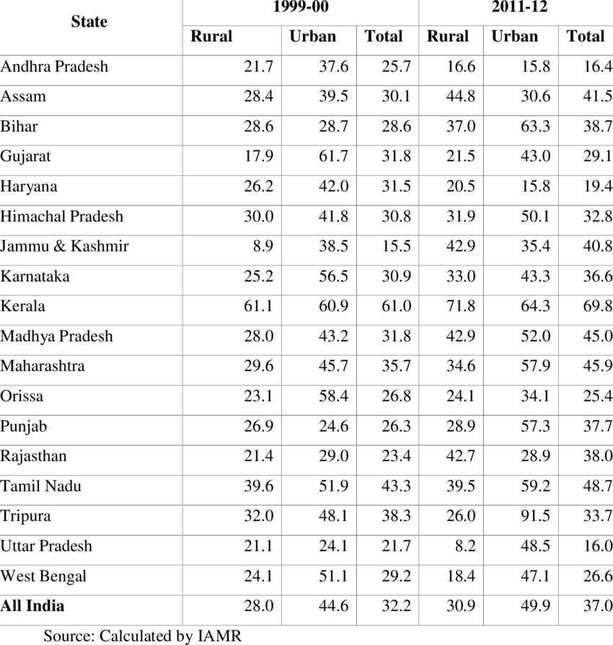
according to 2019 survey
Majority of India still lives in villages and so the topic of rural education in India is of utmost importance. A survey named called the Annual Status of Education Report (ASER), shows that even though the number of rural students attending schools is rising, but more than half of the students in fifth grade are unable to read a second grade text book and are not able to solve simple mathematical problems. Not only this, the level of maths and reading is further declining. Though efforts are being made, they are not in the right direction. The reason cited for this problem in surveys is the increasing number of single classroom to educate students from more than one grade. In some states attendance of teachers and students is also declining. These are a few reasons why schools have failed to educate rural India.
Quality and access to education is the major concern in rural schools as there are fewer committed teachers, lack of proper text books and learning material in the schools. Though Government schools exist, but when compared to private schools then quality is a major issue. Majority of people living in villages have understood the importance of education and know that it is the only way to get rid of poverty. But due to lack of money they are not able to send their children to private schools and hence depend upon government schools for education. Above that, in some of the government schools there is only one teacher for the entire school and if they don’t show up at work, then it is a holiday. If the quality along with number of teachers and, that too committed teachers can be improved in these schools, then aspiring rural children and India can fulfill their dreams of doing something great.
Some government schools in rural India are overly packed with students, leading to a distorted teacher- student ratio. In one such remote village in Arunachal Pradesh there are more than 300 students in class X which makes nearly 100 students in each classroom. In such a situation it is impossible for teachers to pay full attention towards each and every student, even if they are willing to help.
2018 survey from frobes india
India is home to the largest population of children in the world, with an estimated 43 crore/ 430 million children in the age group of 0-18 years in the country. These children are the future of our nation and therefore, it is imperative that they are provided with necessary means to realise their potential. A modernised education system can channelise efforts in this direction. In order to achieve this, it is imperative that we address prevailing teaching-related concerns such as outmoded teaching methods, shortage of qualified teachers, highly disproportionate student-teacher ratio, and inadequate teaching materials that affect the quality of education.
While the ratio of rural-urban enrollment in schools is a massive 7:5, nearly 60 percent of students in rural areas, up to the age of ten, lack basic reading skills. Similarly, despite the improvement in Pupil Teacher Ratio (PTR) from 32 in 2009-10 to 24 in 2015-16, single teacher schools continue to be a major concern in rural parts of the country. Recent numbers point out that there are 97,273 single teacher schools in India, which account for about 8.8 percent of the total schools in the country. These obstacles don’t just lead to poor quality of education, but also contribute to high dropout rates in rural schools—nearly 50 percent by the age of fourteen.
robots used in field of teaching.
1.There are already some examples of social robots beingused in classrooms. One example is Saya, a humanoidrobot deployed in classrooms in Japan to deliver materialabout the principles of leverage, and an introduction torobotics. Saya is a remote controlled humanoid robot witha female appearance. She (or it) consists of a movable headwith the ability to make emotional facial expressions,attached to a manikin body (Hashimoto et al.2011). Anoperator in a control room can hear and observe the stu-dents in the classroom by means of a video camera and therobot’s CCD camera. When the robot is operated in ‘in-teractive’ mode, it can articulate brief sentences andaccompany them with an appropriate facial expression, forinstance telling the class to ‘‘Be quiet!’’ whilst displayingan angry facial expression. Despite this, questionnaireresponses from elementary school pupils indicated that theclass was enjoyable.The Saya robot was presented in the role of a teacher.

2., ‘Rubi’, a low cost ‘so-ciable’ robot, was used to explore whether a robot couldimprove toddlers’ vocabulary skills (Movellan et al.2009).The robot was immersed in an Early Childhood EducationCentre for 2 weeks. It operated autonomously during thisperiod, and could sing and dance; play a physical game oftaking and giving back objects using its physical actuators;and play Flash-based educational games targeting vocab-ulary development. It switched between games dependingon an ‘interest estimator’ which took into account thenumber of faces detected and the number of touchesreceived in the past minute. The researchers reported evi-dence of a 27 % improvement in 18–24 month toddlers’knowledge of the target words taught by the robot ascompared to a matched set of control words that were nottaught

3.Kanda et al. (2004) describe an 18 day field trial at aJapanese elementary school in which two English-speaking‘Robovie’ robots operated autonomously to interact withfirst and sixth grade pupils. The robots could identify thechildren by means of the wireless tags they wore. Therobots spoke English with children that approached it, andhad a vocabulary of around 300 sentences for speaking, and50 words for recognition. A picture-word matching testwas administered to the children before the study, after1 week and after 2 weeks, and the frequency of interac-tions between the children and the robots was recorded.Improvements in English skills as measured by the picture-word matching test were found in those children whointeracted with the robot more often.

4.Thefield trial was performed over an 8 week period in anelementary school in Japan, placing a Robovie robot in aclass with 37 students aged 10–11 years. The children weregiven the opportunity to interact with the robot during thelunch time break. As well as being able to identify thechildren by means of RFID tags, the robot could keep trackof how often individual children interacted with it. It wasprogrammed to exhibit ‘pseudo development’: addingmore behaviours to its repertoire over time.

5.The QRIO robotreceived some input from a human operator specifying awalking direction, head direction, and six different beha-vioural categories (dance, sit down, stand up, lie down,hand gesture and giggle). An automatic giggle reactionwhen its head was patted was set up for the robot, to ensurea contingent response. The researchers claim to have foundevidence of ‘long term bonding’ between the robot and thechildren in their study. The children continued to interactwith the robot over time, and exhibited a variety of socialand care taking behaviours towards the robot. They tou-ched the robot more often than a static toy robot or a teddybear, and the researchers claimed that they came to treat itas a peer rather than as a toy.

6.Tanaka and Matsuzoe (2012)introduced a ‘care-re-ceiving’ robot into an English language school for Japanesechildren. The robot was smaller than the children, mademistakes, and seemed to need their help. 17 children agedbetween 3 and 6 years were involved in the study with theaim of seeing whether the children would learn Englishverbs if they ‘taught’ them to the robot.

7.Telepresence robots represent another form of robots tobe found in classrooms. They have been used to enabletelepresence communication between pupils and remoteteachers and also between pupils in different classrooms.Tanaka et al. (2013) report a study in which a child-oper-ated telepresence robot was used to link remote classroomsof children aged 6–8 years old in Australia and Japan.Their preliminary results suggested that when individualchildren controlled a remote robot to interact with a distantEnglish teacher, they were more engaged than when theyinteracted with the teacher via a Skype screen

8.Telepresence robots differ from the autonomous robotsused in some of the studies described here, in being overtlycontrolled by a human operator. They usually have ananthropomorphic appearance, and some, like the EngKeyand Robosem robots, can operate in either telepresence orautonomous mode (a useful classroom feature when theremote connection breaks down)
Sustainable Learning
Educational Robots can enhance learning in the longer term through the development
of meta-cognition, life skills and learner self-knowledge.
School is not just a place for the acquisition of knowledge and skills. It plays an important part in
the personal development of students. The English National Curriculum (2010) specifically
states the need to help students acquire communication skills, the ability to work with other
people, to present ideas and to be confident.
The way we use educational robots automatically engages students in situations where the
opportunity exists to develop these skills. For example, the Robotic Performing Arts Project
(Catlin 2010) illustrates an opportunity for students to develop their cognitive, social, personal
and emotional skills in an authentic learning situation.
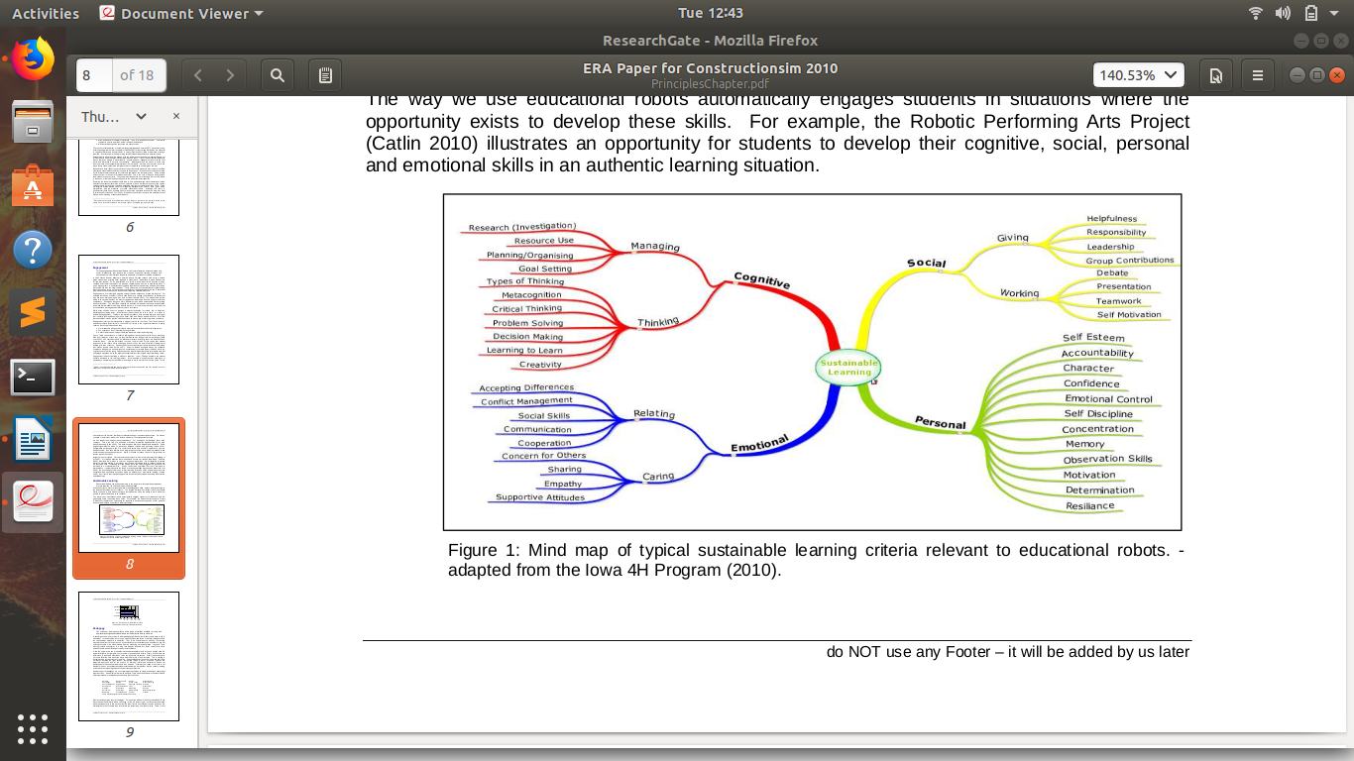

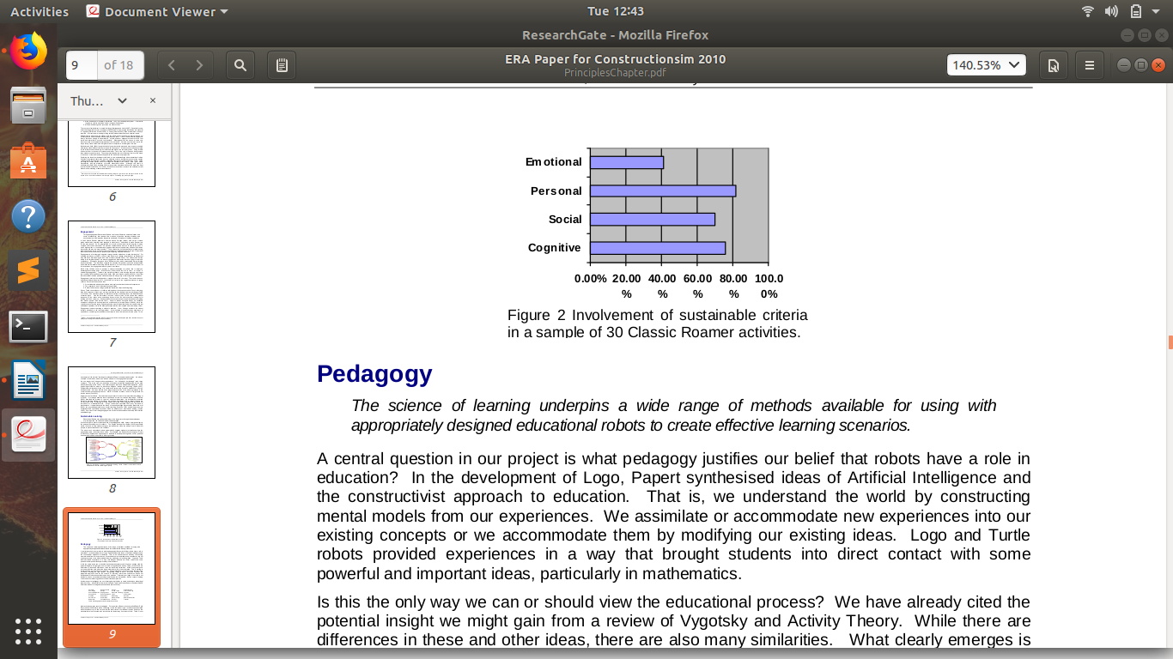
How human intraction with robot is possible

For human–robot interaction (HRI), perception is one of the most important capabilities. This paper re-views several widely used perception methods of HRI in social robots. Specifically, we investigate general perception tasks crucial for HRI, such as where the objects are located in the rooms, what objects are in the scene, and how they interact with humans. We first enumerate representative social robots and summarize the most three important perception methods from these robots: feature extraction,
dimensionality reduction, and semantic understanding. For feature extraction, four widely used signals including visual based, audio-based, tactile-based and rang sensors-based are reviewed, and they are compared based on their advantages and disadvantages. For dimensionality reduction, representative methods including principle component analysis (PCA), linear discriminant analysis (LDA), and locality preserving projections (LPP) are reviewed. For semantic understanding, conventional techniques for several typical applications such as object recognition, object tracking, object segmentation, and speaker localization are discussed, and their characteristics and limitations are also analyzed.
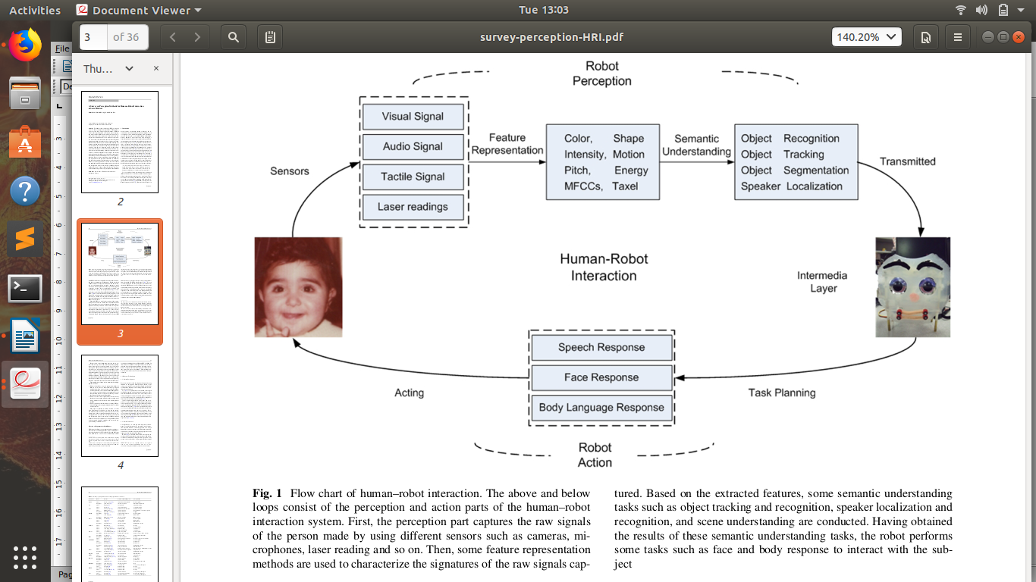

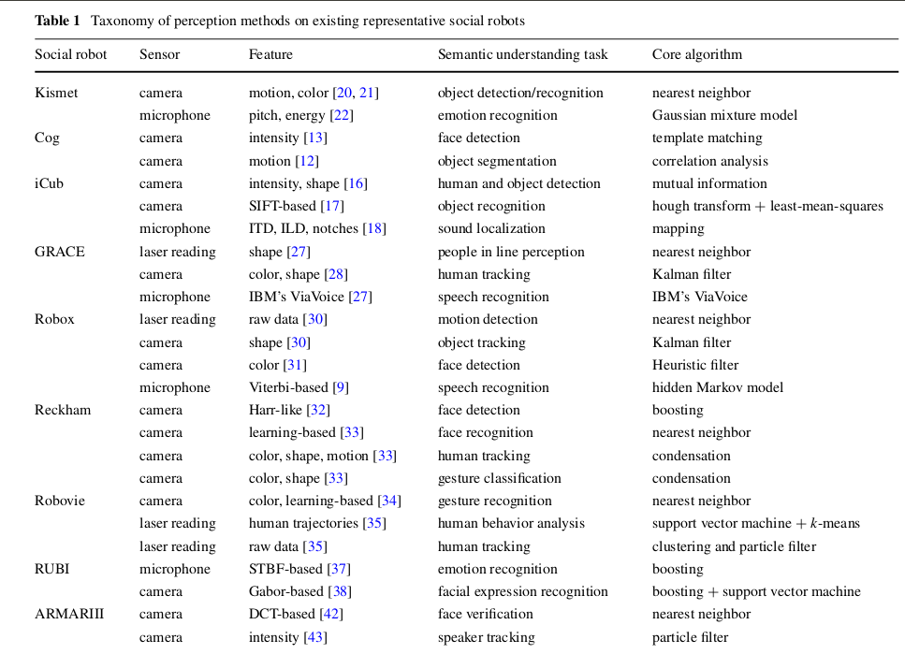
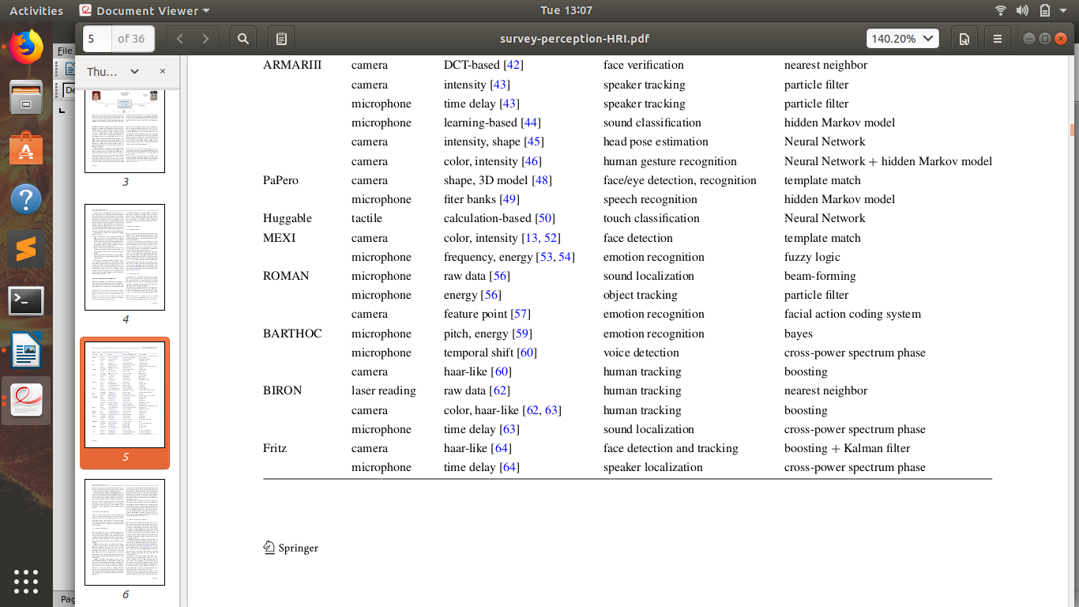

Conclusion
The effectiveness of robots in education programme could be analyzed from different aspects: Study design in order to report meaningful and statistically significant results, robot’s effects on child’s behaviour and development,
relevance of stakeholders’ perception on using robots in and outside of classroom setting, and users’ reaction (especially the children) to the robot’s design. Researchers, majority of whom relied on non-experimental methods, implemented various approach to validate their studies. However this just shows that experimental methods are sorely lacking; quantitative analysis is needed, as pointed by Benitti (2012). In education, the use of robots has the potential to help children develop various academic skills like science process
understanding, mathematical concept development and improvement of achievement scores (Barker & Ansorge, 2007; Williams et al., 2007; Highfield, 2010). In addition, the introduction of robotics in curriculum also increases
children’s interest in engineering. As reported in Chang et al., 2010, the use of robots in education allows children to engage in interactive and engaging learning experiences. Robots seem appropriate to use in language skill development because it allow for a richer interaction (Sugimoto, 2011; Chambers et al., 2008; Bers, 2010; Chang etal., 2010; Young et al., 2010).

